**COAL ASSIGNMENT**

|  |  |
| --- | --- |
| **NAME** | **HAMZA TARIQ** |
| **ROLL NO** | **21i-0707** |
| **Section** | **Y** |

**TASK 01**

;Question 1

.model small

.stack 100h

.data

N db "Hamza Tariq"

CNIC db 3,7,4,0,5,6,9,7,5,3,7,2,3

age db 20

College db "Punjab College"

University db "FAST Islamabad"

Experience db 02

post db "MANAGER"

.code

mov ax, @DATA

mov ds, ax

mov ax,0

mov si,offset N

mov si,offset age

mov si,offset CNIC

mov si,offset College

mov si,offset University

mov si,offset post

mov ah,4ch

int 21h

end

**NAME:**

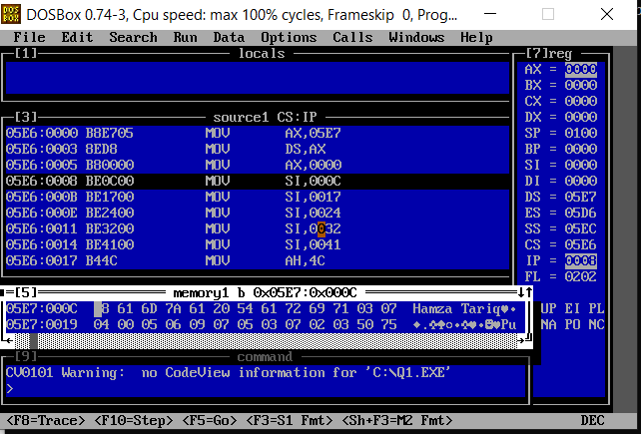

**Age:**

**College:**

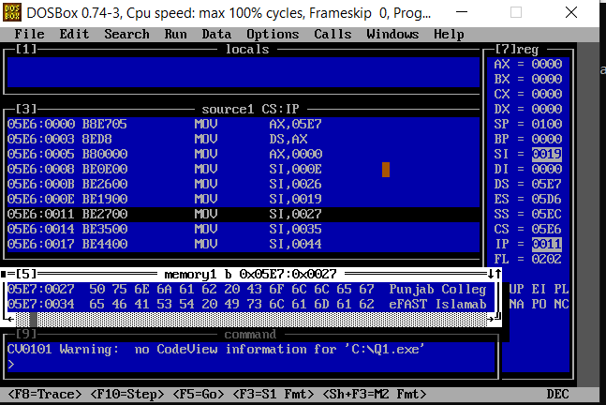

**CNIC:**

**University:**

**Post:**

**TASK 02**

.model small

.stack 100H

.data

var db ?

.code

mov ax, @data

mov ds, ax

mov ax,0

mov ah, 2ch

int 21H

mov var,dh

mov si,offset var

mov ah, 4ch

int 21H

end

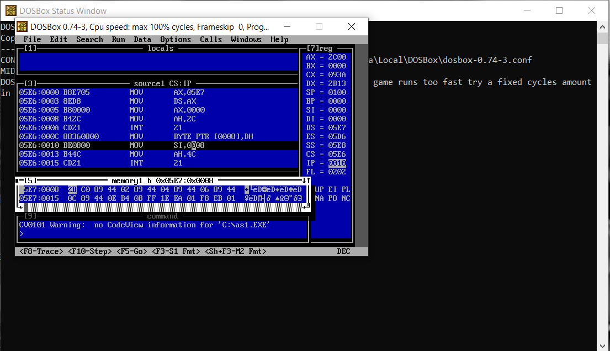

**TASK 03**

.model small

.stack 100h

.data

Array dw 1234H

var1 db ?

var2 db ?

sm db 0

.code

mov ax, @DATA

mov ds, ax

mov si,0

mov bl,16

mov ax,Array[si]

mov ah,0

div bl

add sm,ah

add sm,al

mov cl,al

mov al,ah

mov ah,0

mul bl

add al,cl

mov var1,al

inc si

;======================================

mov ax,Array[si]

mov ah,0

div bl

add sm,ah

add sm,al

mov cl,al

mov al,ah

mov ah,0

mul bl

add al,cl

mov var2,al

mov cl,var2

mov ch,var1

mov Array,cx

mov si,offset sm

mov si,offset Array

mov ah,4ch

int 21h

end

**TASK 04**

.model small

.stack 100h

.data

Array db "Madam,I'm Adam"

Arrcpy db Lengthof Array dup (0)

Find db "P"

.code

mov ax, @DATA

mov ds, ax

mov ax,0

mov si,offset Find

mov cx,lengthof Array

mov si,0

mov di,0

Start:

mov al,Array[si]

inc si

mov ah,40H

cmp al,ah

ja check1

jmp exit

check1:

mov ah,5AH

cmp al,ah

jb insert

cmp al,ah

ja check2

jmp exit

check2:

mov ah,60H

cmp al,ah

ja check3

jmp exit

check3:

mov ah,7AH

cmp al,ah

ja exit

insert:

mov Arrcpy[di],al

inc di

exit:

Loop Start

mov si,0

mov cx,di

mov bl,32

st1:

mov al,Arrcpy[si]

cmp al,5BH

jb chng

jmp e

chng:

add al,bl

mov Arrcpy[si],al

e:

inc si

LOOP st1

mov ax,0

mov si,0

mov cx,di

dec di

compare:

mov al,Arrcpy[si]

mov ah,Arrcpy[di]

cmp al,ah

je incr

mov Find,'N'

incr:

inc si

dec di

loop compare

mov si,offset Find

mov ah,4ch

int 21h

end

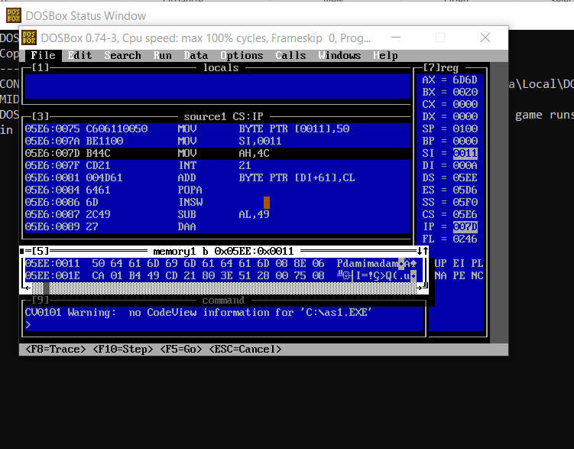

**NOTE:**

If entered string is a palindrome then I mov true(P) in find otherwise N(not palindrome)

**TASK 05**

.model small

.stack 100h

.data

Array1 db 1H,2H,3H,4H,5H,6H,7H,8H,9H

Array2 db 1H,2H,3H,4H,5H,6H,7H,8H,9H

Array3 db 0,0,0,0,0,0,0,0,0

.code

mov ax, @DATA

mov ds, ax

mov si,0

mov di,8

mov cx,9

Start:

mov al,Array1[si]

mov ah,Array2[di]

add al,ah

mov Array3[si],al

inc si

dec di

Loop Start

mov si,offset Array3

mov ah,4ch

int 21h

end

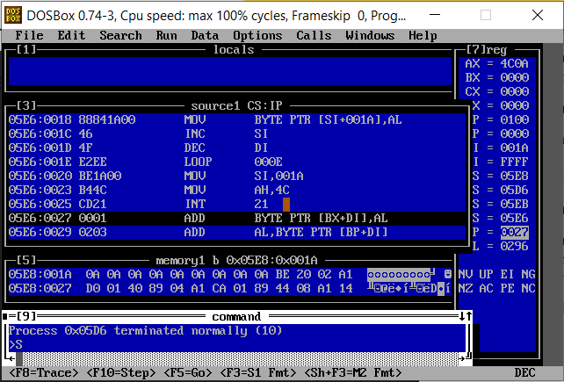

**TASK 06**

.model small

.stack 100H

.data

Array db 1H,2H,2H,4H,2H,6H,2H,8H,9H

counter db (0)

maxcounter db (0)

num db (0)

.code

mov ax, @data

mov ds, ax

mov ax,0

mov si,0

mov cx,9

Start:

mov al,Array[si]

mov bx,cx

mov cx,9

mov di,0

Inner:

mov ah,Array[di]

cmp al,ah

je match

jmp E

match:

add counter,1

E:

inc di

LOOP Inner

mov dl,counter

cmp dl,maxcounter

ja b

jmp eb

b:

mov maxcounter,dl

mov num,al

eb:

inc si

mov counter,0

mov cx,bx

LOOP Start

mov si,offset num

mov ah, 4ch

int 21H

end

